**Dear Prospective Ball Person:**

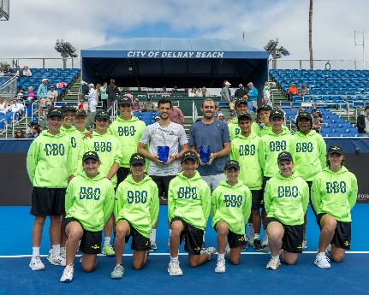The 2025 **Delray Beach Open** will be held at the Delray Beach Stadium & Tennis Center, February 7– 16 and features the world’s only 10-day tennis event consisting of the below:

* **LEGENDS EVENT** (Feb. 7–9, 2025) featuring former tennis greats such as the Bryan Brothers, Tommy Haas, Jack Sock, the Jensen Brothers & more.
* **ATP WORLD TOUR EVENT** (Feb. 10 – 16, 2025) featuring top-world ranked ATP Professionals such as Taylor Fritz and Tommy Paul & more.

## We are very proud of our ball person team here at the event and know that if you are selected, you will have a wonderful experience in teamwork with us. This email contains FOUR (4) documents: Cover letter, **APPLICATION**, release form, and **waiver.** Make sure you print out all 4!

Your volunteer package will include clothing, meals, parking tickets (for those who drive) and of course the best seat in the house -- ON COURT!

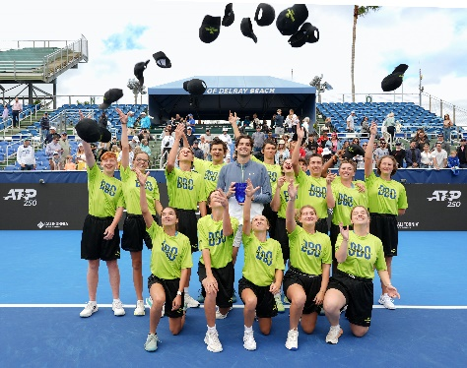Our Ball Persons tickets/credentials for Stadium has changed this year due to making a large portion of the bleachers reserved SEATS. From Friday, 2/7 through Tuesday, 2/11 your badge will be valid for General Admission (GA) Stadium Seating. No badges are valid after Tuesday, 2/11 for stadium access. From Friday, 2/7 through Friday,2/14 DAY SESSION, ball persons will receive ONE complimentary GA ticket for stadium for each session they work. From FRIDAY, 2/14 NIGHT through SUNDAY, 2/16 FINALS, each Ball Person will receive ONE GROUNDS ticket for each session they work. There is no stadium access but there are big screens on the grounds for a parent/friend to watch!

**Completed applications must be returned to me by JANUARY 10, 2025 .** Photo ID badges are required. Please enclose **TWO** **PASSPORT OR SCHOOL PHOTOS ONLY** with your application. **Please put your**

**NAME** on the back of pictures and **MAIL** your **application, release** and waiver with your **TWO** photos to:

**Monica Sica, 12926 Briarlake Dr. #103, Palm Beach Gardens, FL 33418. Faxes/emails are not accepted nor will any applications without release and pictures attached.** I appreciate your cooperationwith this.AND DO NOT RETURN THIS LETTER TO ME. This is for you to keep with all info re trainings etc.

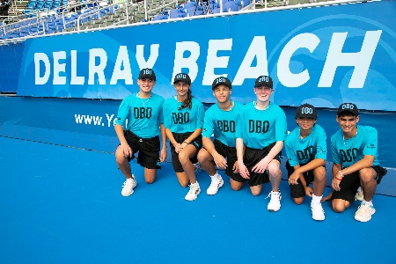

***Mandatory Training/Tryouts Sessions***

**Sat., January 18th, 11:30am - 1:30pm, Sat., January 25th 1:30 - 3:30pm** and **Saturday**, February 1st, 11:30 AM to 1:30 PM at the Delray Beach Stadium & Tennis Center (201 W. Atlantic Ave.). Experienced ball persons (2 or more DBO tournaments) need to attend one session. One DBO Tournament – need to attend 2 sessions. First time ball persons (no experience) are required to attend all 3 sessions. **EVERYONE** returning an application needs to attend a training/practice session(s). MANDATORY!

***Uniforms and Schedule Pick-up***

**Sat., Feb. 1, 2025.** Immediately follows the training session, upstairs in the clubhouse. (Pro shop) We look forward to a great tournament and seeing you at the practice sessions. If you have any questions, please email me: [**ITCBallkids@aol.com**](mailto:ITCBallkids@aol.com) or call/text at (561) 866-6433, preferably email. Please identify yourself!

Monica ~ Monica Sica, Director of Ball Persons